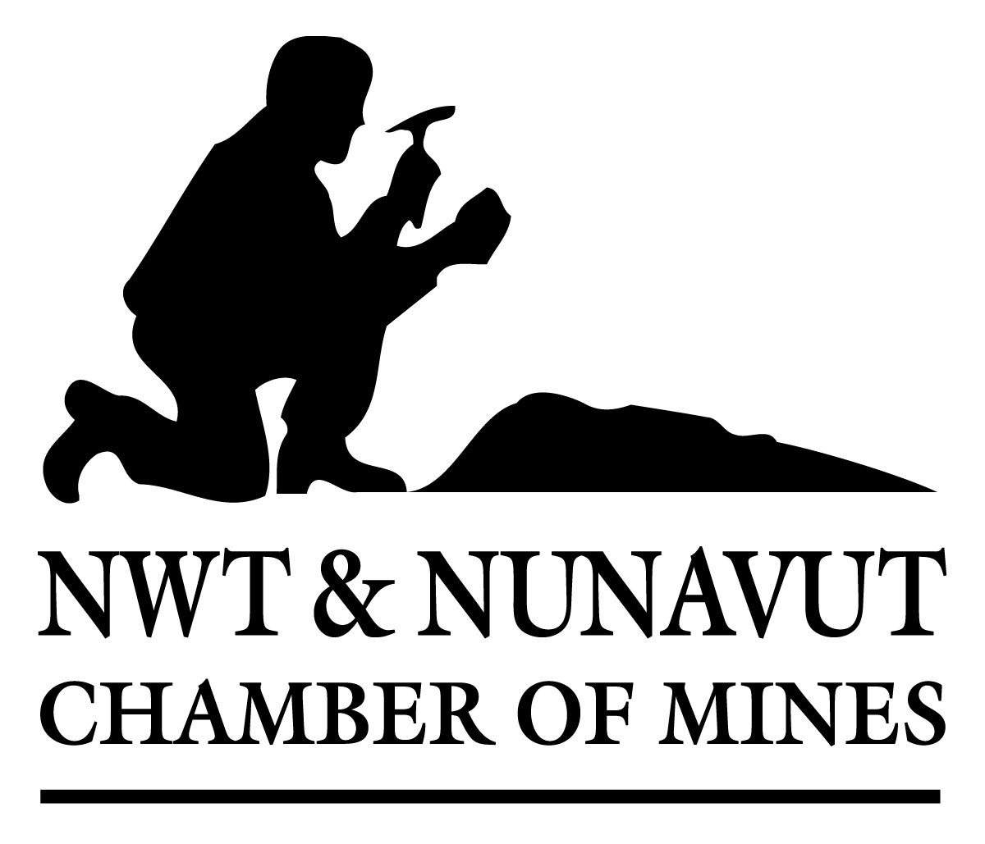

Presentation to the Senate Committee on Energy,
The Environment and Natural Resources

Concerning Bill C –33
An Act respecting the water resources of Nunavut
and the Surface Rights Tribunal and to make consequential
amendments to other Acts.

by
Mike Vaydik
General Manager
NWT & Nunavut Chamber of Mines

December 10, 2001

Requirement for Legislation

The geology of Nunavut is among the most prospective in the world. While Nunavut has already enjoyed substantial production of precious and base metals, its future potential may be even more diverse. Exploration projects currently underway encompass a wide variety of mineral productions, including gold, nickel, platinum group metals, tantalum and diamonds.

By its very nature, mineral exploration is a high-risk activity. The Canadian experience, which is echoed worldwide, tells us that less than one of every 1000 prospective mineral showings ever results in a producing mine.

This is what we miners call “geological risk”. Geological risk is something that is generally well accepted, and usually well understood.. More difficult to understand and assess are other forms of risk that increasingly affect the outcome of mineral exploration and development initiatives. What I’m talking about are political risk and legal risk.

The 1993 Nunavut Land Claims Agreement represents a significant milestone in reducing the political risk associated with mineral exploration and mine development.

But what about legal risk? Can the same thing be said? Unfortunately, the answer is a resounding no.

And why is this the case? The answer, short and simple, is that none of the new legislation promised by, and indeed required by, the Nunavut Land Claims Agreement has yet been passed.

You are well aware that the bill which is before you, Bill C-33, represents both the first of this series of new statutes, as well as the third attempt over the past five years to pass critically needed water legislation.

This is not a record that Canadians can be proud of. The situation is more concerning when one remembers that there are at least two more key statutes to come, one dealing with land use planning and the other with impact assessment.

These unfortunate circumstances mean that legal risk in Nunavut remains high, thereby potentially negating the competitive advantage that Nunavut should be enjoying as a result of having settled the land claim.

These circumstances are not conducive to the long term economic and social well-being of the territory, and do little to benefit Canadians at large. They are all the more frustrating when you remember that a workable, statute-based regime for water management existed in the Nunavut Settlement Area from 1972 until 1996.

Exploration and Economic Potential

The stakes are high because when success does come, the benefits can be enormous. Even sustained exploration programs can generate substantial economic benefits. Exploration alone brings about $125 Million to the economy of the Northwest Territories and Nunavut every year. While final figures are not yet in, Nunavut is estimated to have received approximately half of this total in the year 2000.

Fortunately, exploration stage expenditures are a good match with services and facilities that that the Territory’s developing economy is able to provide. These include camp supplies and services, aircraft charters, expediters, hotel facilities and restaurant services. The benefits to Nunavut residents will increase as the business sector in Nunavut develops to better service the needs of the industry.

But to sustain this growth, the needless risk from the absence of key regulatory legislation needs to be resolved. This is especially true as projects in Nunavut reach more advanced stages.

The current band-aid approach may not have inhibited early-stage exploration thus far, but neither has it made the process any easier. The absence of clear regulatory procedures is never desirable from an administrative perspective. And even the perception of potential problems may be sufficient to cause companies to think about investing exploration dollars elsewhere.

In fact, CEO’s of a number of junior Canadian mining companies have told me of their reluctance to put hard-won capital resources at risk in Nunavut until a basic regulatory regime, comparable to other Canadian frontier areas, is put in place.

Key elements are access to land, environmental impact assessment, and perhaps most important of all, a regime for regulating water use and waste disposal that goes far beyond the makeshift process now in place under Article 13 of the Nunavut Land Claims Agreement.

Mining’s Economic Potential

To appreciate the benefits that Nunavut could enjoy from future mining development, we need only look at the two major diamond projects that are now in place in the NWT.

The Ekati diamond mine owned by BHP/Billiton has been in production for two years and employs about 600 people. Of these, 70% are northerners of and 40% of the northerners are aboriginal.

The nearby Diavik project is currently under construction. More than 1000 people have been on site at peak periods. About 40% are northerners and of those about half are aboriginal. During the operation phase, Diavik expects to have about 400-450 workers. It anticipates about 40% of its total workforce will be northern aboriginal. It anticipates up to 18 apprenticeships annually. It will pay about $40 million in salaries annually. It will purchase about $100 million in supplies and equipment annually.

Once both properties are operational, it is estimated that Canada will produce between 10 and 15 per cent of the world’s gem quality stones.

This is only a partial list of the extensive benefits to the NWT economy, and to aboriginal communities in particular, that diamond exploration and development have brought. There are many more that I would be glad to discuss at the Committee’s request.

Business Opportunities

Unprecedented steps are being taken by mining companies to encourage northern aboriginal companies to participate in their business.

Contracts have been split to allow small northern and aboriginal companies to bid. Joint ventures with established southern firms are encouraged to help get inexperienced northern firms through the steep learning curve of servicing a large fast - paced development scenario.

Aboriginal businesses are responding as never before. From catering companies, trucking of ore to the process plant, geotechnical services, engineering, surveying, site logistics, construction, welding and steel fabrication and security services; northern companies are involved. Many of these are either wholly owned by aboriginal corporations or are joint ventures. Two aboriginal companies are involved in diamond cutting and polishing ventures.

To indicate how far things have come, there is even talk of equity participation in mining ventures.

These developments indicate the scale of benefits that will hopefully accrue to Nunavut as they have to the NWT.

Conclusion

Nunavut has enormous mineral potential that can be developed to help sustain a viable economy. Mining has been and can continue to be a major part of that economy. In 1999, mining contributed about $130 million to Nunavut’s economy. Only government is bigger.

Two of Nunavut’s three mines will close during the next year. To be sustainable, the mining industry needs a competent regulatory environment, both to encourage exploration and to promote projects to production.

Industry worked well under the NWT Waters Act. It needs a prompt return to a good regime of water management legislation. It needs Bill C – 33 to be enacted as soon as possible so that the minerals industry can continue to provide employment and business opportunities to residents and revenue to governments at all levels.

I urge you to give every consideration to advancing this key piece of legislation to Royal Assent and proclamation.

Thank you for your attention.

